Progress Database Server Machine Configuration

Progress Database

Creating The Database

First create a void database from a structure definition (ST) file.

The following example is from the MOI DVU2 database and this was created from the starting point of the “sports2000” demo database’s ST file.

# Sample Structure Description File: sports2000.st
#
# The following defines the Primary Recovery Area consisting of one
# variable length extent. It resides in the /usr2/bi directory:
#
#b /usr2/bi
b .
#
# The following defines the Schema Area consisting of one variable length
# extent, residing in the current working directory:
#
d "Schema Area" .
#
# The following defines three fixed length After Image Areas each equal to
# 1 MB in size:
#
#a /usr3/ai f 1024
#a /usr3/ai f 1024
#a !./usr3/ai data. f 1024
a . f 1024
#
# The following defines a Transaction Log Area equal to 4 MB in size and
# residing in the current working directory. This storage area is used
# for 2 phase commit:
#
t . f 4096
#
# The following defines six Application Data Areas each with one fixed
# length extent equal to 1 MB in size and 1 variable length extent:
#
#d "Employee",32 /usr1/emp f 1024
#d "Employee",32 /usr1/emp
#
#d "Inventory",32 /usr1/inv f 1024
#d "Inventory",32 /usr1/inv
#
#d "Cust_Data",32 /usr1/cust f 1024
#d "Cust_Data",32 /usr1/cust
#
#d "Cust_Index",32 /usr1/cust f 1024
#d "Cust_Index",32 /usr1/cust
#
#d "Order",32 /usr1/ord f 1024
#d "Order",32 /usr1/ord
#
#d "Misc",32 !./usr1/misc data. f 1024
#d "Misc",32 !./usr1/misc data.
d "MOITestArea",32 . f 1024
d "MOITestArea",32 .
#
# Note that the directory pathname for the .Misc. application data area
# contains spaces, and to recognize that the pathname is specified with
# an ! (exclamation point) and . . (quotation marks).

prostrct <DB Name> <Structure File> -blocksize <n>

Where n is one of 1024, 2048, 4096, 8192.

E.g.

prostrct create dvu2 ./dvu2.st -blocksize 4096

Now copy in the metaschema structures: -

procopy $DLC/empty<n> <DB Name>

Where <n> is 1, 2, 4, 8 and is the block size in Kb

E.g.

procopy $DLC/empty4 dvu2

Start the database and log into the new database with your Unix user id using a blank password.

PATH=$PATH:$DLC:$DLC/bin ; export PATH
PROCFG=$DLC/prodev.cfg ; export PROCFG
#numformat=44,46 ; export numformat
mpro <DB Name> -d dmy -yy 1915 -Mm 4096 -T /tmp

E.g.

PATH=$PATH:$DLC:$DLC/bin ; export PATH
PROCFG=$DLC/prodev.cfg ; export PROCFG
#numformat=44,46 ; export numformat
mpro dvu2 -d dmy -yy 1915 -Mm 4096 -T /tmp

NOTE: use PuTTY instead of Reflections terminal emulator so that the F keys work correctly OR configure Reflections correctly as the default configuration does not work well with this application.

Navigate to Tools->Data Dictionary
Navigate to Admin->Security->Change Your Password…

Change your password to a non blank value.

Starting Up The Database

Log in to STAUDDBCP01.

cd /export/home/<DB Name>

# Primary 4GL Broker
proserve <DB Name> -d dmy -yy 1915 -N TCP -S <port number>
# Secondary 5GL / SQL Broker
proserve <DB Name> -d dmy -yy 1915 -N TCP -S <port number> -m3

E.g.

# Primary/4GL Broker
proserve dvu2 -d dmy -yy 1915 -N TCP -S 30001
# Secondary/SQL Broker
proserve dvu2 -d dmy -yy 1915 -N TCP -S 30002 -m3

Note: a utility shell script, called “startbrokers.sh” has been created, in each database’s directory, that performs the above commands for that database.

Creating The SQL DBA User

Connect to the database using the character mode multi user application: -

PATH=$PATH:$DLC:$DLC/bin ; export PATH
PROCFG=$DLC/prodev.cfg ; export PROCFG
#numformat=44,46 ; export numformat
mpro dvu2 -d dmy -yy 1915 -Mm 4096 -T /tmp

Enter the user name and password of the database creator. This is the Unix user ID used in the database creation step and the password set for this user, above.

NOTE: use PuTTY instead of Reflections terminal emulator so that the F-keys work correctly OR configure Reflections correctly as the default configuration does not work well with this application.

Navigate to Tools->Data Dictionary
Navigate to Admin->Security->Edit User List

Select ‘Add’ from the list of commands and create the user SYSPROGRESS with a password of SYSPROGRESS.

The SYSPROGRESS user has predefined DBA privileges (for the SQL-92 interface to Progress) but the user does not exist in new databases.

Creating The MOI ETL User

Connect to the new database using the SQL-92 interface as user SYSPROGRESS.

Create the MOI ETL user “moietl” with password “moietl” using SQL commands: -

CREATE USER ‘moietl’, ‘moietl”;
COMMIT;

Give the new user the ability to create and drop objects using SQL commands: -

GRANT RESOURCE TO moietl;

Shutting Down The Database

Log in to STAUDDBCP01.

cd /export/home/<DB Name>

proshut <DB Name>

Then enter choice 2 (Unconditional Shutdown).

Dropping The Database

Log in to STAUDDBCP01.

prodel <Db Name>

E.g.

prodel dvu2

OpenLink ODBC Middleware

Starting The License Manager

Log in to STAUDDBCP01.

cd /export/home/openlink/bin
./oplmgr +start

Stopping The License Manager

Log in to STAUDDBCP01.

cd /export/home/openlink/bin
./oplmgr +stop

Starting The Request Broker

Log in to STAUDDBCP01.

cd /export/home/openlink/bin
nohup ./oplrqb -fd >oplrqb.log 2>&1 &

Stopping The Request Broker

Log in to STAUDDBCP01.

cd /export/home/openlink/bin
./oplshut

Defining Data Sources

Log in to STAUDDBCP01.

cd /export/home/openlink/bin

DSNs

Edit the DSN configuration file “odbc.ini”.

Add/delete DSNs as required.

PF Files

Create a (PF) parameter file for the database that you want to define. It should contain the following text: -

-db <DB Name> -N TCP -S <Broker Port Number> -H <Server Name/IP Address>
-ld <Logical DB Name>

E.g.

-db dvu2 -N TCP -S 30000 -H myserver
-ld dvu2

The PF files will be referenced in the Options field when we connect to the database using JDBC/ODBC using the OpenLink middleware.

The use of PF files is the method defined by Fathom (the Remix vendors) but PF files and custom OpenLink rule book entries are not strictly required. Instead we could use the standard Progress rule book instead.

OpenLink Request Broker Rule Book

Edit the OpenLink Request Broker configuration file “oplrqb.ini”.

Add/delete entries as required in the following sections: -

[Domain Aliases]

Add a custom domain alias in the form: -

<DB Name> = <DB Name>

[Mapping Rules]

Add a custom mapping rule in the form: -

<DB Name>:*:*:*:*:*:* = accept generic_<DB Name>

In the Generic Settings section (search for “;; GENERIC SETTINGS”) add a section in the form: -

[generic_<DB Name>]
Description = Default settings for Progress 9.1D agent
Program = pro91d_sv
Environment = <DB Name>
ServerOptions = -T /tmp -d mdy -TB 31 -TM 31 -q -NL -Mm 1024
Directory = /tmp
ReUse = never
Userid =
Password =

[Environment <DB Name>]
DLC = /export/home/dlc91d
PROCFG = /export/home/dlc91d/client.cfg
MIN_FIELD_LEN = 2000
CURSOR_SENSITIVITY = LOW

Save the files and then validate your changes by running

./inicheck

Check the output for issues relating to the changes you’ve made and the stop and restart the OpenLink Request Broker (see below).

More information from http://support.openlinksw.com/opie/kbase/293: -

Rules Book: Understand the Complete Session Rules Book
The OpenLink Session Rules Book (oplrqb.ini) resides in the /bin sub-directory of your OpenLink server components installation. The OpenLink Request Broker uses the Rules Book to resolve ODBC calls. Therefore, you must insure that this file is properly configured.
To proceed, use vi or Notepad to open your Rules Book. Then, insure that the following key sections are present and customized for your particular environment:
1. The [Environment] section contains all the environmental variables that are necessary to establish a connection. For example:
[Environment PROGRESS83A]
DLC = C:\DLC
Path = C:\DLC\BIN;C:\WINNT\System32 ;
TABLEVIEW = ;
TABLEVIEW_QUALIFIER = Y ;
DEADLOCK_TIMEOUT = 60 // Semicolons are comments! ;INSERT_LOGICAL = Y // Remove semicolons to make variables visible! ;
UPDATE_LOGICAL = Y ;
MIN_FIELD_LEN =
2. [Domain Aliases] resolves all names, which you pass in the Domain section of your client's DSN. Typically, the resolution is an abbreviated form of the original parameter. For example:
Progress 83A = pro83a
3. [Mapping Rules] establishes one or more authentication rules for each alias. In other words, it accepts or rejects connections by comparing the user's connection options with rules defined by the Rules Book administrator. For example:
pro83a:*:*:*:*:msaccess:* = reject generic_pro83a pro83a:*:*:*:*:*:* = accept generic_pro83a
Here, the first rule blocks all DSN's associated with MS Access. However, the second rule permits access in all other scenarios. If you would like additional information on mapping rules, please consult OpenLink's How-To on this subject.
4. The generic agent configuration section designates which OpenLink agent will be spawned for a particular connection. Additionally, you may hardcode a variety of connection options into the [generic] section. Be advised: All hardcoded options hardcoded override options passed in the client DSN.
[generic_pro83a]
Program = pro83a_sv.exe
Environment = PROGRESS83A
ServerOptions = -q -d mdy -TB 31 -TM 31
ReUse = ifsame machine, ifsame application
;Directory = c:\temp
;ConnectOptions =
;ReadOnly =
;CommandLine =
;Database =
;UserID =
;Password =
Finally, you must restart your Broker to initialize changes made to your Rules Book.
Note: These examples pertain to use of the Rules Book with Progress 83A. However, the Rules Book contains sample sections, which demonstrate which environmental variables are necessary for which databases. It also provides templates and guidance for formulation of aliases, rules, and agent configuration.
Creating Remix Tables

FTP the file “newmiccs.pf”, in ASCII mode, to the database server machine.

Start the Data Administration tool (pro or mpro) and select Tools->Data Dictionary.
Then select Admin->Load Data and Definitions ->Data Definitions (.df file)…

Enter the path and name of the “newmiccs.pf” file. Then press the OK button. The tables are then created.

Granting Privileges On The Remix Tables

We now need to grant privileges to the MOI ETL user (MOIETL).

Connect to the database as the SYSPROGRESS user using the SQL-92 interface (the DataDirect ODBC driver or the SQL-92 JDBC driver). The preferred tool for this step is SquirrelSQL as the Progress SQL Explorer tool has no interface to the Windows clipboard!

Run the following query: -

SELECT 'GRANT INSERT,UPDATE,DELETE,SELECT ON pub."' || tbl || '" TO moietl;'
FROM sysprogress.systables
WHERE owner = 'PUB'
AND tbl NOT LIKE '\_%' ESCAPE '\'
;

Copy the output rows and paste them into the command editor panel and execute the list of statements.

Progress Client Machine Configuration

Installing Progress Client Software

From

\\stafs04\oneplandev2\MOI\Software\Progress\From Fathom Technology\PROGRESS 9.1e\Client\91E Win32 Intel

Run “setup.exe”.

When prompted by this dialogue box: -

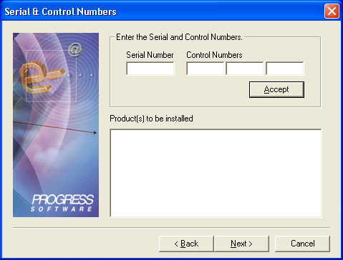

Enter the following: -

Serial Number: 003566722
Control Numbers: X6CS9 - 6PZAN - 3MRYP

In the subsequent dialogues enter the following

LANGUAGE: English-International
CODEPAGE: ISO8859-1
DATE: dmy
NUM-FORMAT: COMMA, PERIOD (i.e., 1,234.99)

Installing OpenLink Client Software

OpenLink ODBC driver.

From

\\stafs04\oneplandev2\MOI\Software\Progress\From Fathom Technology\BUPAopl\Client

Run the installer file “nto3zzzz.msi”.

Reboot if/when when prompted.

OpenLink JDBC driver.

Copy the file “opljdbc3.zip” from

\\stafs04\oneplandev2\MOI\Software\Progress\From Fathom Technology\BUPAopl\Client

to a local directory on your machine.

Creating A Data Direct ODBC DSN To the Progress Database

NOTE: Use this type of DSN to reverse/forward engineer to/from ERwin to the Progress database.

From the Windows Control Panel->Administrative Tools->Data Sources (ODBC).

Create a new User or System DSN.

Select the driver “DATADIRECT 4.10 32BIT Progress SQL92 v9.1E”.

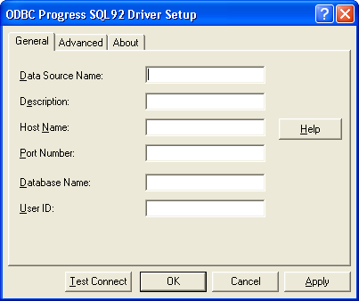

Enter a name for the data source (E.g. DVU2DataDirect) then the host name, TCP port number, database name and login user ID (e.g. MOIETL). Press the Test Connect button and enter the password (e.g. MOIETL).

Creating An OpenLink ODBC DSN To the Progress Database

NOTE: Use this type of DSN to query the database using the same mechanism as is used in the production data extraction mechanism as used by the ODI Topology.

From the Windows Control Panel->Administrative Tools->Data Sources (ODBC).

Create a new User or System DSN.

Select the driver “OpenLink Generic ODBC Driver (6.0)”.

Enter a name for the data source (E.g. DVU2OpenLink) then the host name (STAUDDBCP01) and TCP port number of the OpenLink Request Broker (5000) separated by a colon character (“:”).

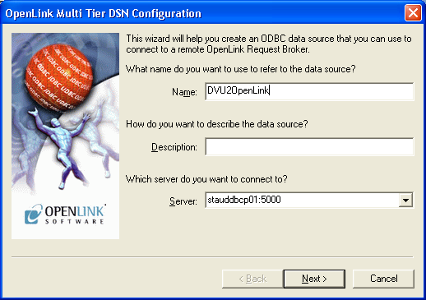

Enter the name of the database in the domain field (instead of a database type) and instead of entering Progress server parameters specify the “-pf” switch and then the parameter file of the database. Also enter a valid user name and password to test the connection. E.g.: -
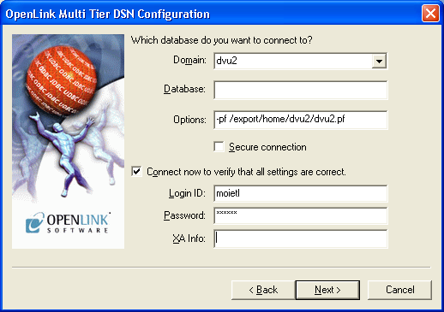

On the next dialogue leave all the fields with their default values.

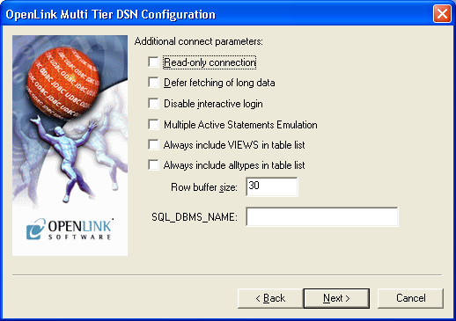

On the next dialogue press the “Test Data Source…” button to test the connection.
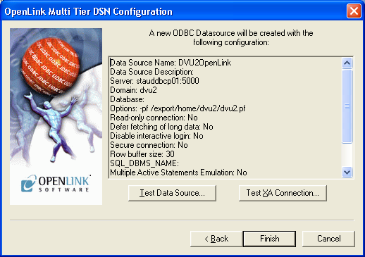

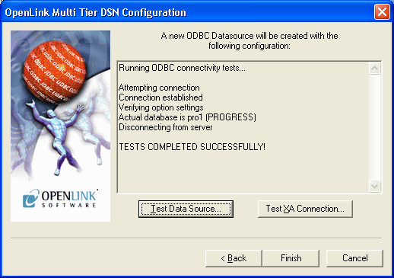

Click “Finish”.

Creating A Progress JDBC Connection To the Database From Windows

Ensure that the “bin” directory path of the Progress Client installation has been added to the PATH environment variable either for the command window session or a surrounding batch file or at the system level via the Control Panel (Control Panel->System->Advanced-Environment Variables). This is to include the file “JdbcProgress.dll”.

Ensure that the file “jdbc.jar” from the “java” directory of the Progress Client installation has been added to the “java” command line (via the –classpath / -cp switch) or added to the CLASSPATH environment variable for the command window session or a surrounding batch file or at the system level via the Control Panel (Control Panel->System->Advanced-Environment Variables).

The connection URL format is as follows: -

jdbc:JdbcProgress:T:host-name:port#:database-name [User-ID password]

E.g.

jdbc:JdbcProgress:T:stauddbcp01:30004:dvu2

or

jdbc:JdbcProgress:T:stauddbcp01:30004:dvu2 moietl moietl

Creating A Progress JDBC Connection To the Database From Unix

Ensure that the file “jdbc.jar” from the “java” directory of the Progress Client installation has been added to the “java” command line (via the –classpath / -cp switch) or added to the CLASSPATH environment variable for the command window session or a surrounding shell script or at the system level via the /etc/profile script.

Ensure that the “lib” directory path of the Progress Client installation has been added to the LD_LIBRARY_PATH environment variable. Do this by adding “$DLC/lib” to the LD_LIBRARY_PATH value if DLC is defined else add the path directly. This is to include the file “libJdbcProgress.so”.
The connection URL format is as follows: -

jdbc:JdbcProgress:T:<host>:<port number>:<DB name> [User-ID password]

E.g.

jdbc:JdbcProgress:T:stauddbcp01:30004:dvu2

or

jdbc:JdbcProgress:T:stauddbcp01:30004:dvu2 moietl moietl

Creating An OpenLink JDBC Connection To the Database From Windows

Ensure that the file “opljdbc3.zip” of the OpenLink Client installation has been added to the “java” command line (via the –classpath / -cp switch) or added to the CLASSPATH environment variable for the command window session or a surrounding batch file or at the system level via the Control Panel (Control Panel->System->Advanced-Environment Variables).

The connection URL format is as follows: -

jdbc:openlink://<host>:<port>/SVT=<DB Name>/Options=-pf {<PF File path and name>}

E.g.

jdbc:openlink://stauddbcp01:5000/SVT=dvu2/Options=-pf {/export/home/dvu2/dvu2/pf}

NOTE: that this format is using the custom OpenLink Rule Book entry rather than a generic server type entry. SVT stands for SerVer Type.

Creating A Progress JDBC Connection To the Database From Unix

Ensure that the file “opljdbc3.zip” of the OpenLink Client installation has been added to the “java” command line (via the –classpath / -cp switch) or added to the CLASSPATH environment variable for the command window session or a surrounding batch file or at the system level via the /etc/profile script.

The connection URL format is as follows: -

jdbc:openlink://<host>:<port>/SVT=<DB Name>/Options=-pf {<PF File path and name>}

E.g.

jdbc:openlink://stauddbcp01:5000/SVT=dvu2/Options=-pf {/export/home/dvu2/dvu2/pf}

NOTE: that this format is using the custom OpenLink Rule Book entry rather than a generic server type entry. SVT stands for SerVer Type.

